Ag team is preparing for up coming competiton at sandiego fair June 24-30
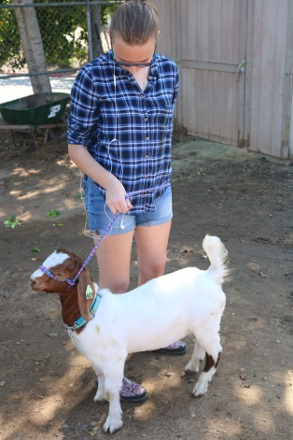
Sophomore Kendra May practices with her goat Billy in preperation for their next competition.

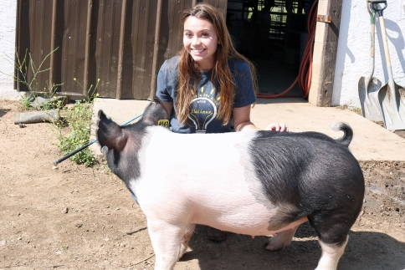
Junior Jordyn Callahan poses wih her pig Penelope . Just like she recently did at Escondido High School competiton on May. 10. Iliad/Eric Gant
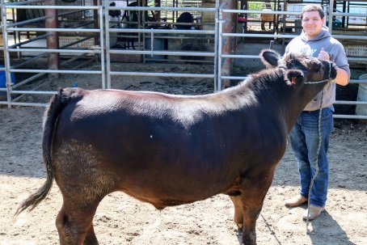
Senior Cody Nelson shows his well-trained steer Bruce.
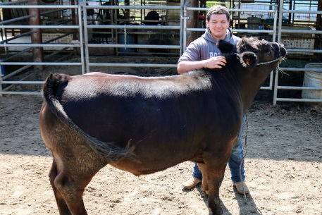
Senior Cody Nelson and his steer Bruce waiting for their picture to be taken before competition
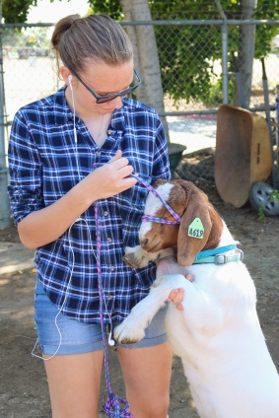
Sophomore Kendra May and her goat Billy stand tall because of their recent success at agriculture show at Escondido High School on Friday May 10th.

